**TAC, Job server, TDS, TDP, IAM, (Nexus) Installation Implementation**

**(8.0.1)**

**Installation Guide & Documentation**

Contents

Section 1: Introduction ……………………………………..3

Section 2: Prerequisites……………………………………..4

Section 3: Installation………………………………………..4

Section 4: Configuration…………………………………….9

Approval

| Signatures by each signatory indicate their acceptance that this document is complete and accurate to the best of his/her knowledge per responsibilities outlined in this document and as guided by approved methodologies and established procedures. | | |
| --- | --- | --- |
| Talend Lead:  Artha Emp | **Subhransu** | **Date:** |
| Project Manager:  Artha Emp | **Deepthi Dharamsagar** | **Date:** |
| Talend developer:  Artha Emp | **Omkar Patil** | **Date:** |

# **Section 1: Introduction**

**Talend Data preparation**

Talend Data Preparation is a self-service application that enables information workers to cut hours out of their workday by simplifying and expediting the laborious and time-consuming process of preparing data for analysis or other data-driven tasks. Talend Data Preparation runs on top of the Talend Integration Platform and delivers enterprise-class capabilities together with connectivity to virtually any data source. It fosters collaboration between business people who know the data best and central organizations, like IT or Risk Management, that define the rules and policies for data accessibility and governance.

It includes:

* Integration and cataloging.
* Data Discovery and Profiling.
* Cleansing, standardizing and shaping.
* Enriching and connecting datasets.
* Operationalizing Data Preparation.

**Talend Data Stewardship**

Data stewardship is the practice of ensuring an organization’s data is accessible, trustworthy, usable, and secure. It oversees every stage of the data lifecycle: creating, preparing, using, storing, archiving, and deleting duplicates, in accordance with an organization’s established data governance principles for promoting data quality and health.

**Data stewardship encompasses:**

* Knowing and documenting what types of data an organization possesses (and the quality of the data)
* Understanding where data assets are located and monitoring the use of data.
* Ensuring high-quality data is accessible, usable, safe, and trusted — quickly identifying data quality issues.
* Enforcing data policies, business rules, and initiatives around how a company’s data can be used.
* Helping the organization make most of its business data for competitive advantage.
* Ensuring stakeholders, data owners, and business users create a data-driven culture.

**Installation Environment**

DEV Environment

# **Section 2: Prerequisites**

**Download & Configure Java**

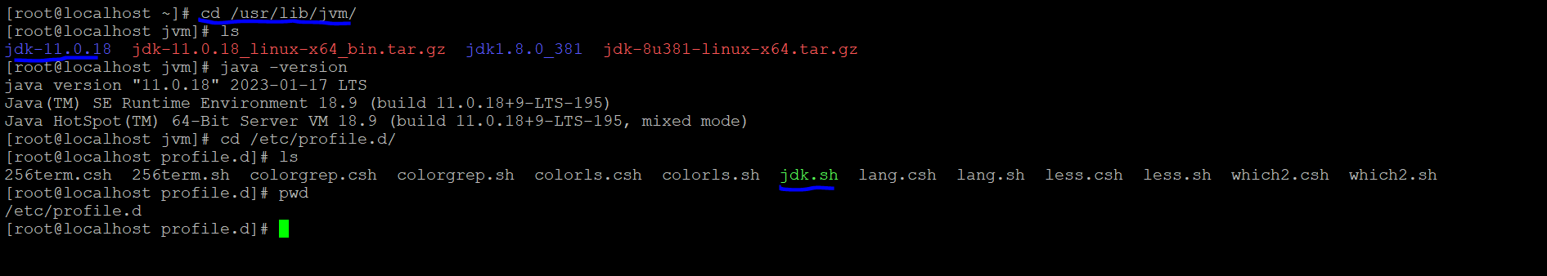

# **Section 3: Installations**

#make a directory of talend folder and keep all the Talend Installations files in it.

Files: - dist, license, Talend-Installer-20211109_1610-V8.0.1-linux-x64-installer.run

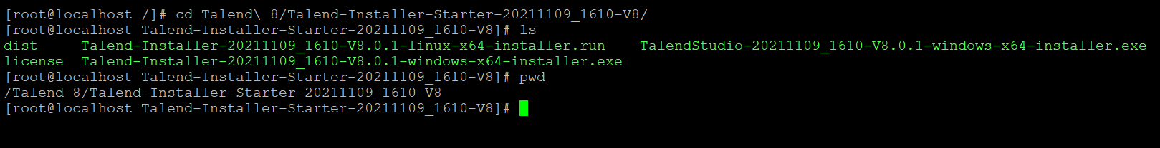

# Run the Linux Installation file.

./Talend-Installer-20211109_1610-V8.0.1-linux-x64-installer.run

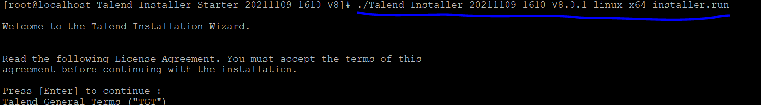

:

[1] Server - Install all server modules using default settings.

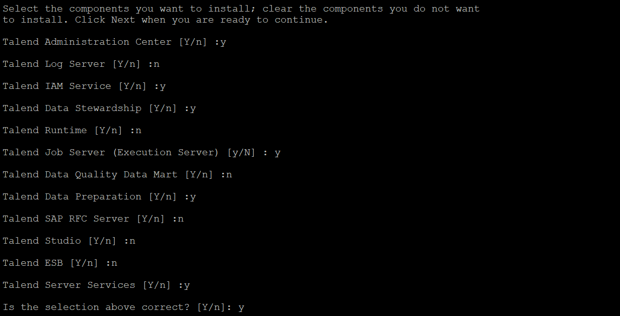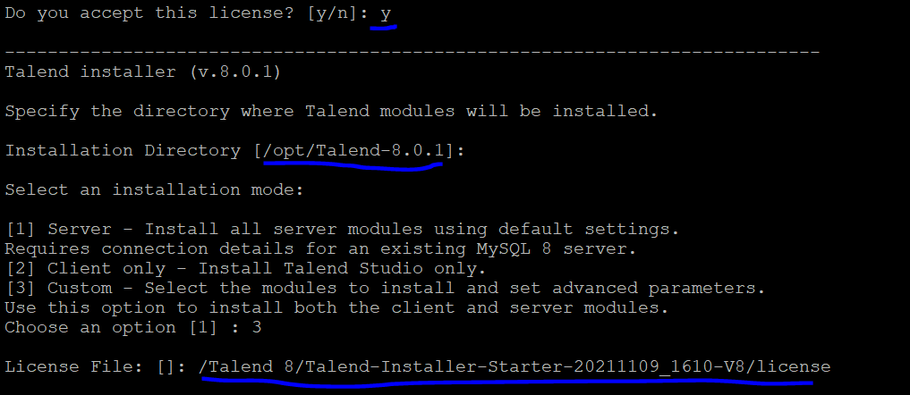

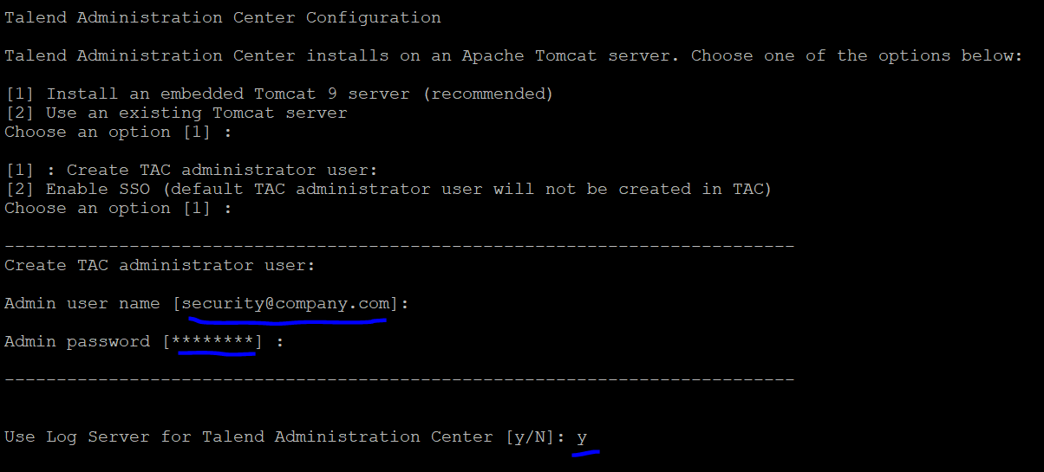

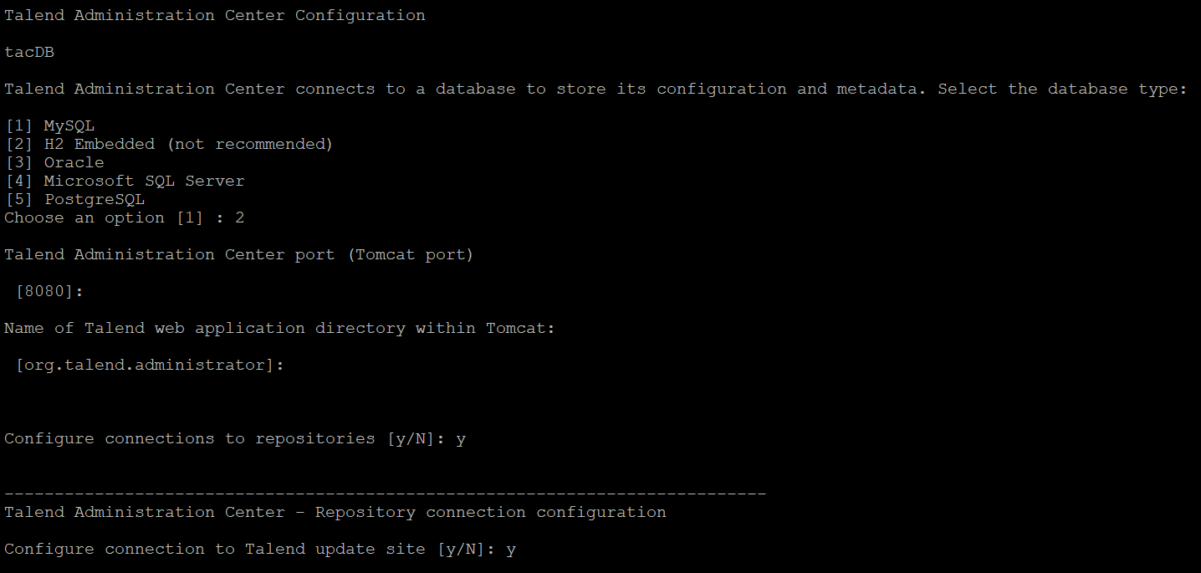

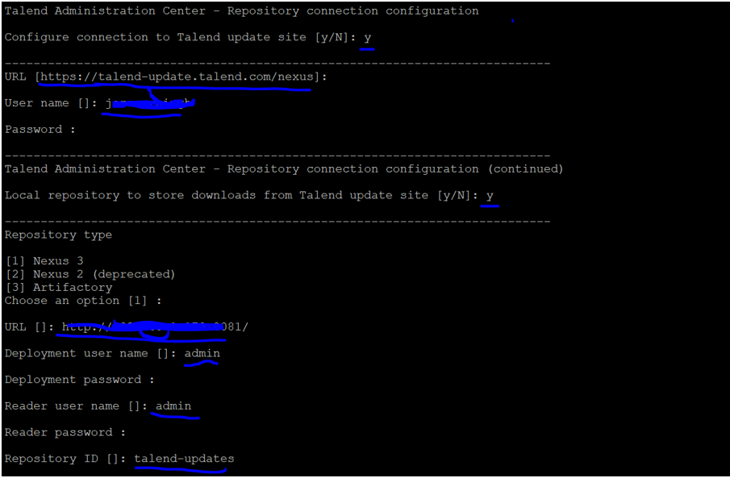

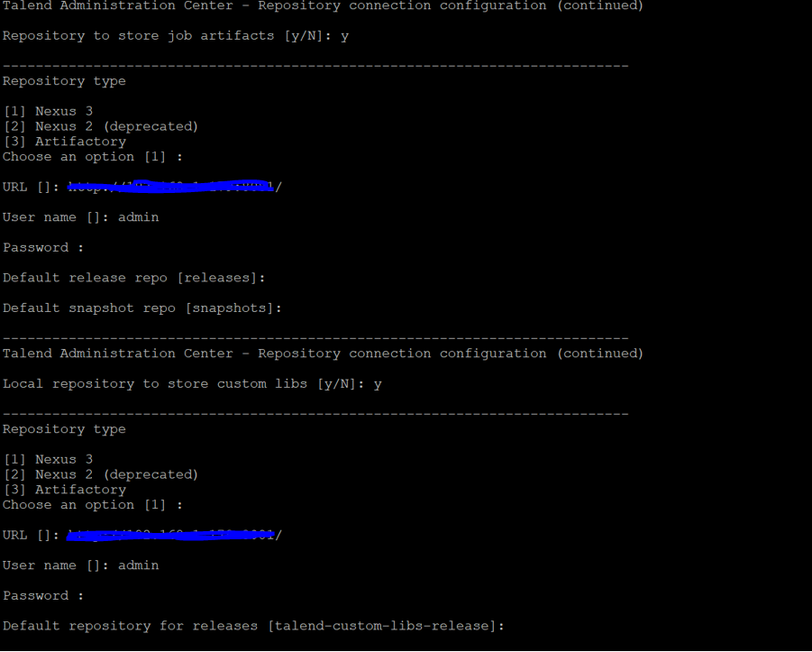

# Talend Identity and Access Management

Select Tomcat for IAM application

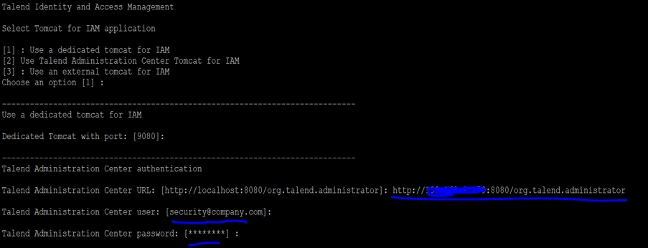

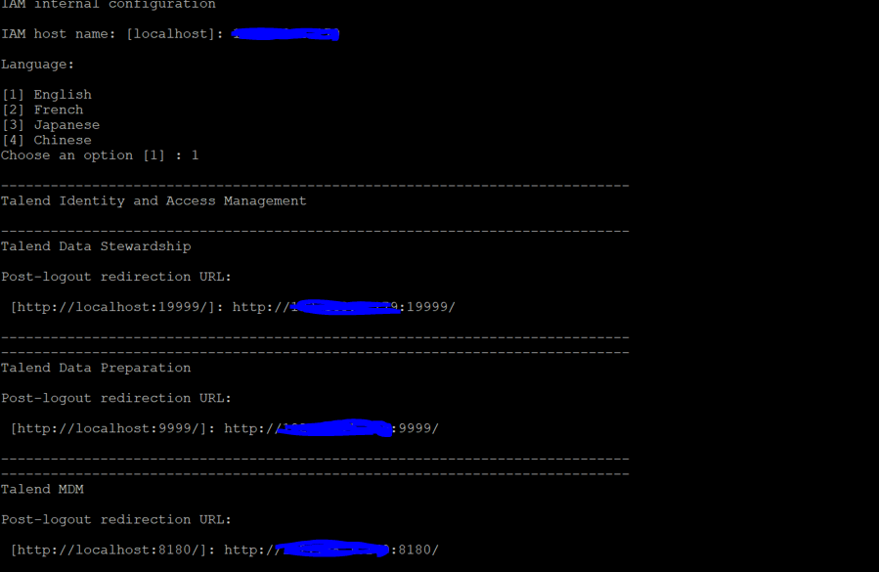

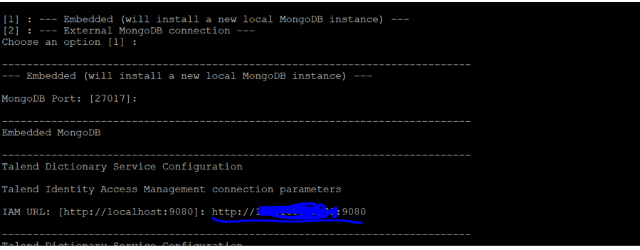

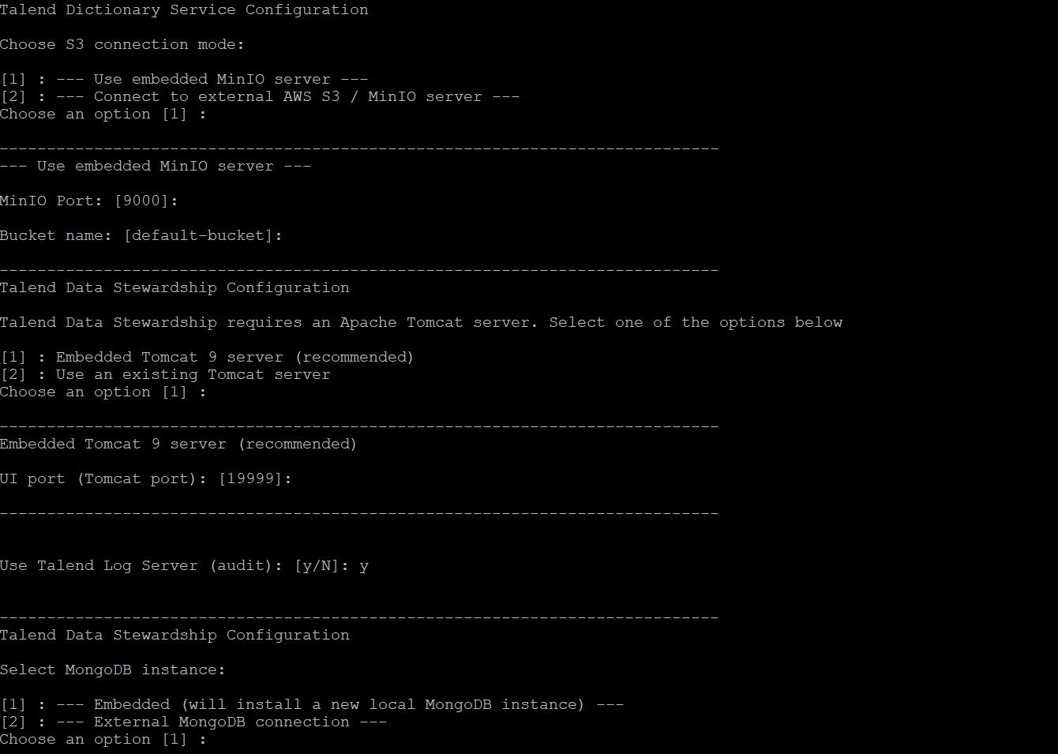

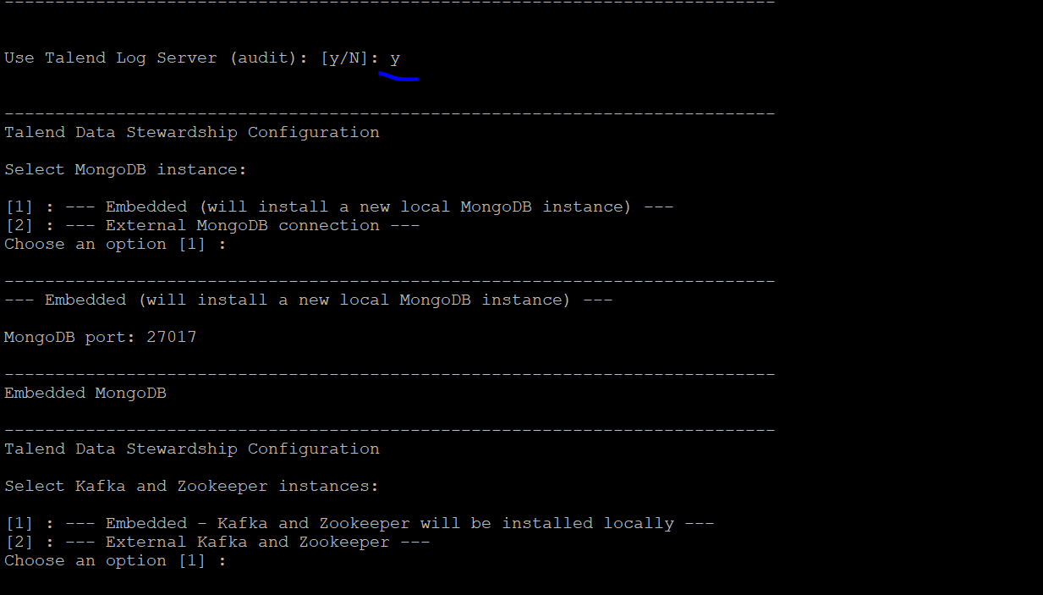

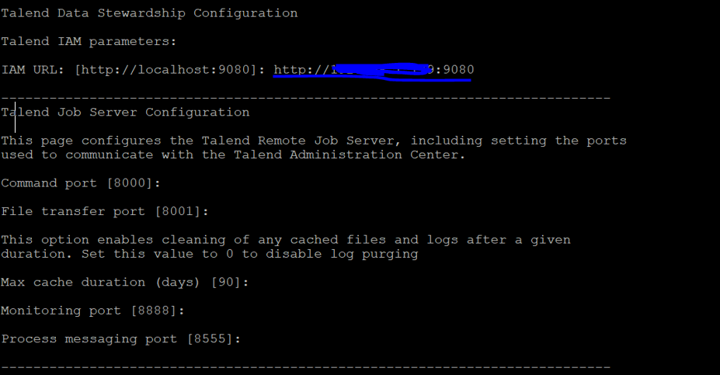

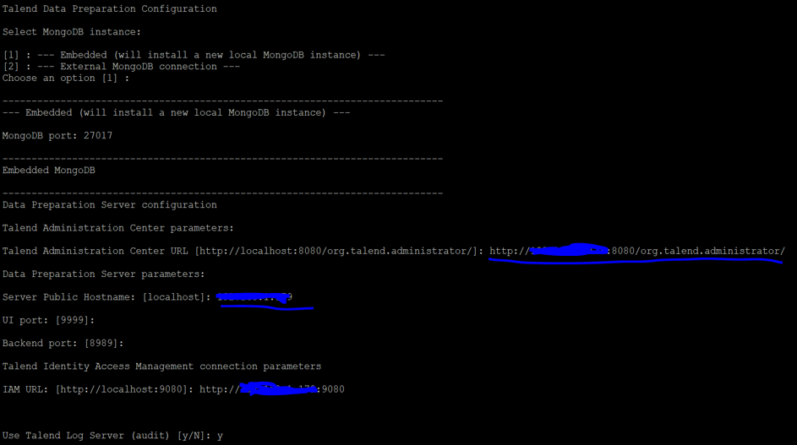

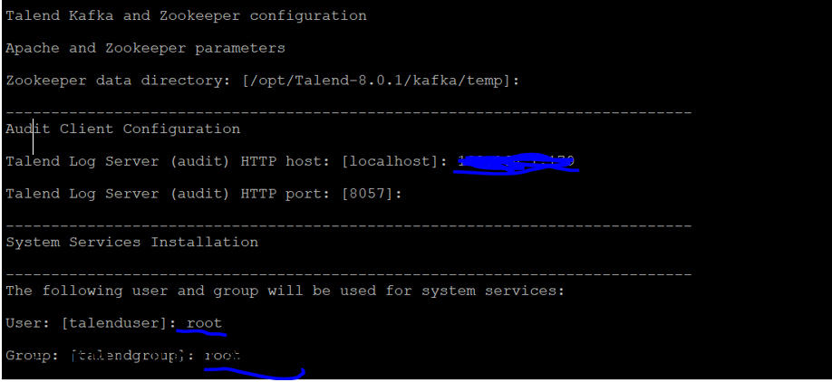

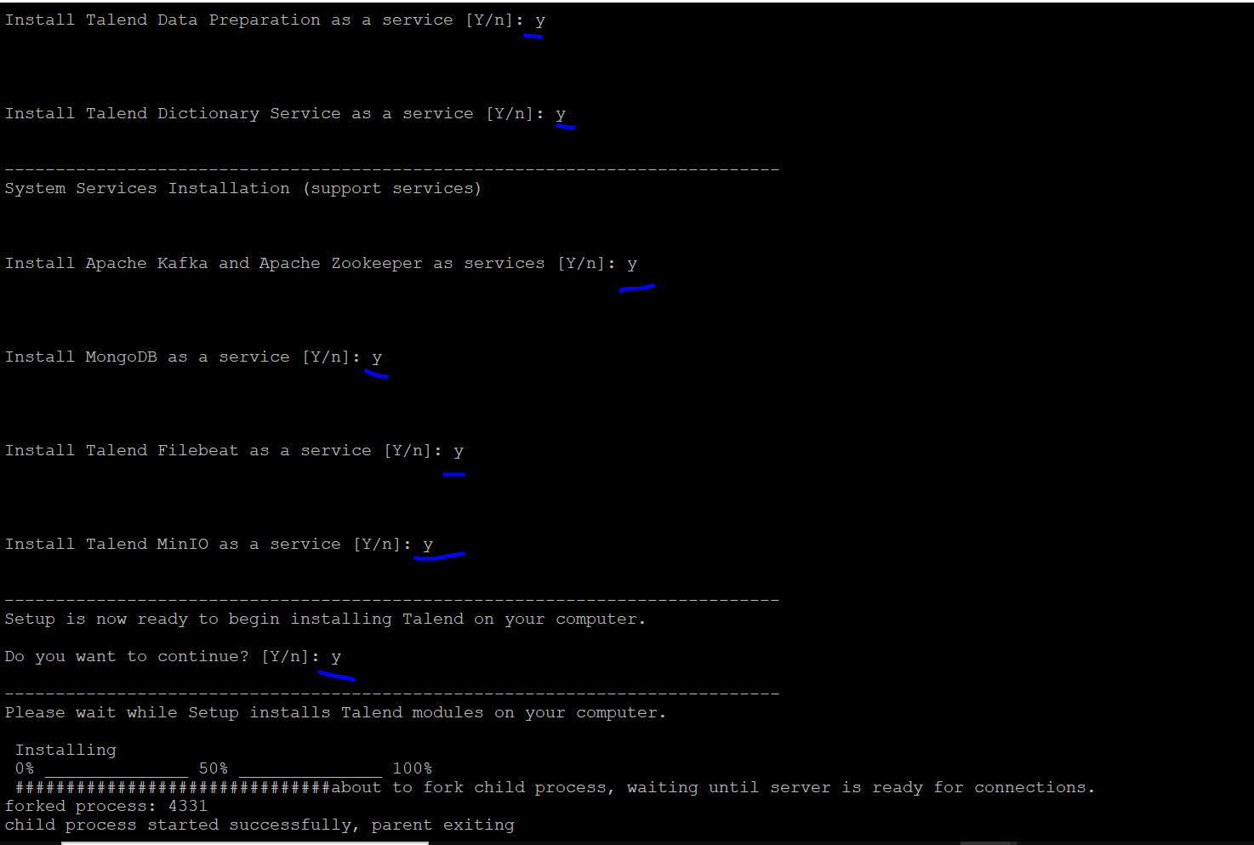

============================================

# TAC memory setting

cd /opt/Talend-8.0.1/tac/apache-tomcat/bin

vi setenv.sh

xms size 2G and xmx sixe is 12G

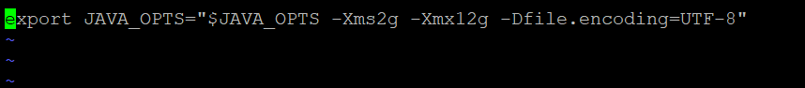

# Apply IPV4 settings from Jared

cd /etc/sysctl.d

vi 90-keepalive.conf

net.ipv4.tcp_keepalive_intvl = 60

net.ipv4.tcp_keepalive_probes = 30

net.ipv4.tcp_keepalive_time = 180

*SAVE*

*run*

sysctl -f 90-keepalive.conf

==================================================

# check all the services

cd /etc/system/system

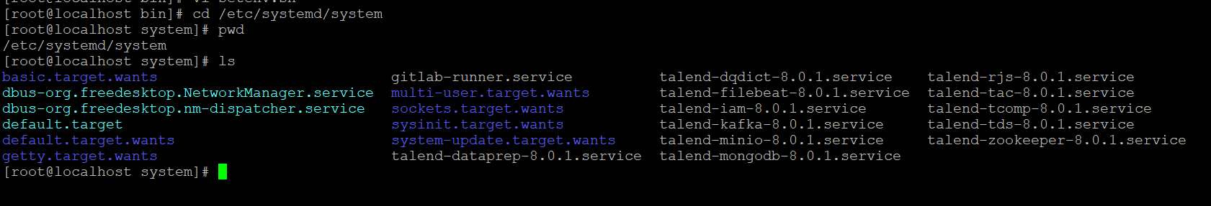

============================================

#check all the services are running.

sytemctl status talend*

============================================#create the logs directories

cd /srv/

mkdir fileshare

cd fileshare

mkdir Talend

Audit - /srv/fileshare/Talend/Audit/reports

Job Conductor - /srv/fileshare/Talend/Administrator/generatedJobs

Job Conductor - /srv/fileshare/Talend/Administrator/executionLogs

Logs - /srv/fileshare/Talend/Administrator/executionLogs/technicalLog/technical.log

Logs - /srv/fileshare/Talend/Administrator/executionLogs/businessLog/business.log

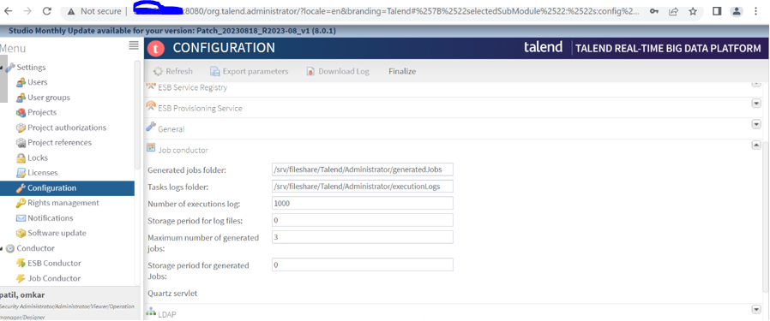

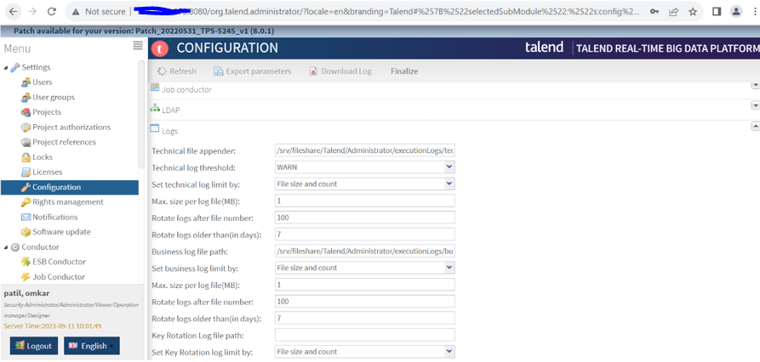

# IAM url login

http:{ip_address}:9080/syncope-console

note: default username and password

username: - admin

password: - password

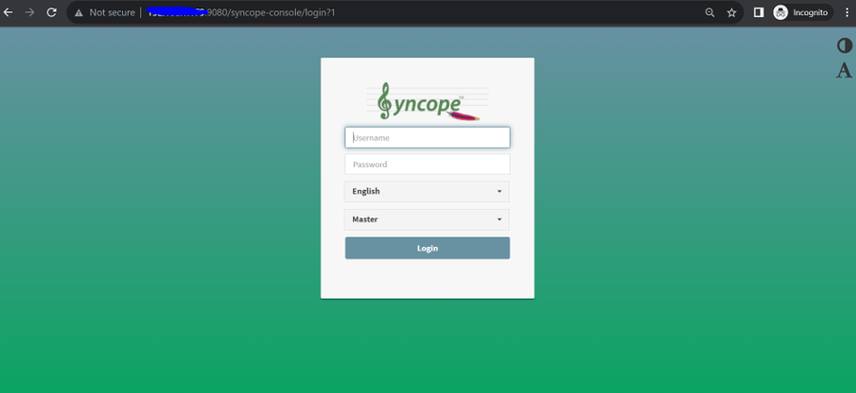

# TDS url

http:{ip_address}:19999/

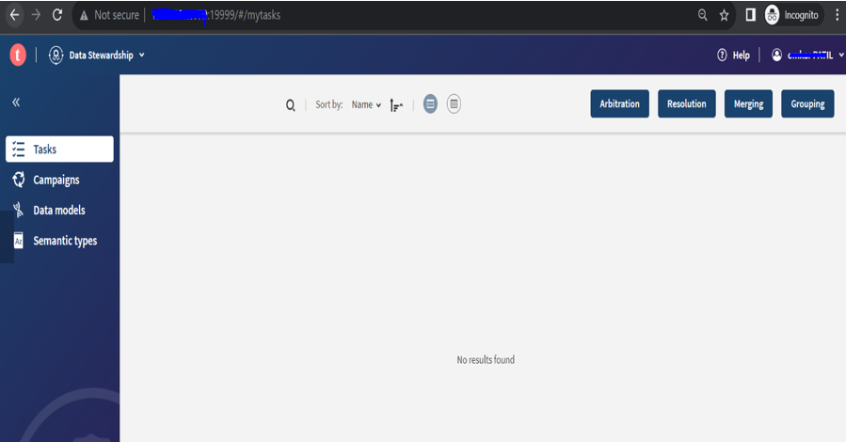

# TDP url

http:{ip_address}:9999/

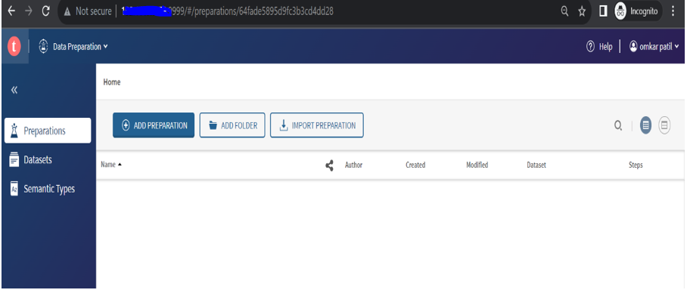

#Nexus url

http:{ip_address}:8081/

